Teaching the True Science of Weather by Mike Thompson
It is more crucial than ever for parents to take control of educating their children and preparing them for challenging the world view of many of their peers. Too often, facts are dismissed in favor of emotion. It is hard enough being a kid, let alone being one that is facing the insanity of the world today. Kids are often told one thing at home, but another thing entirely by society. It is easy for them to become confused and question their beliefs.
Parents need all the help they can get. You are taking on a relentless battle that will challenge your patience and resolve every day!
The good news is that you are making a difference when you take the time to talk to your kids and teach them at home.
Over the years. in my capacity as an on-air meteorologist, I had countless opportunities to speak to students and teach them about weather and science. In those settings, I could always tell which kids had parents who taught them respect, discipline, and discernment. Those kids were invariably the ones who were able to grasp the more complex concepts I was speaking to them about. Those kids had a distinct advantage over the other students. And, it usually wasn't even a close call.
I see that even more distinctly today. Science, and the scientific method have been replaced with social-emotional learning. The laws of physics are being dismissed by those who want to use their own set of “facts”. The problem with that sort of narcissistic view of science is that God created this place where we all live, and He is the one who determines the truth! Refuting that truth is futile.

Your daily conversations with your kids make a huge difference. Even if it may not feel that way at times. So be encouraged by the simple fact that you are making the effort to be involved in their lives and their education. It will pay off!! Have faith!
I decided to do my part by providing an educational platform called IQ Weather. I have worked in the field of meteorology for over 40 years, and wanted to share what I learned over those many decades with families.
My career in meteorology began working aboard an aircraft carrier providing weather data and forecasts for flight operations. I then went on to work at five different television stations across the country…the last 36 years of which were as a Chief Meteorologist.
When you work in a particular field of science that is tough and challenging, you realize the importance of being objective and using your knowledge to make important decisions. I had to do that on a daily basis making forecasts, warning of severe weather, and helping people plan their lives around the weather.
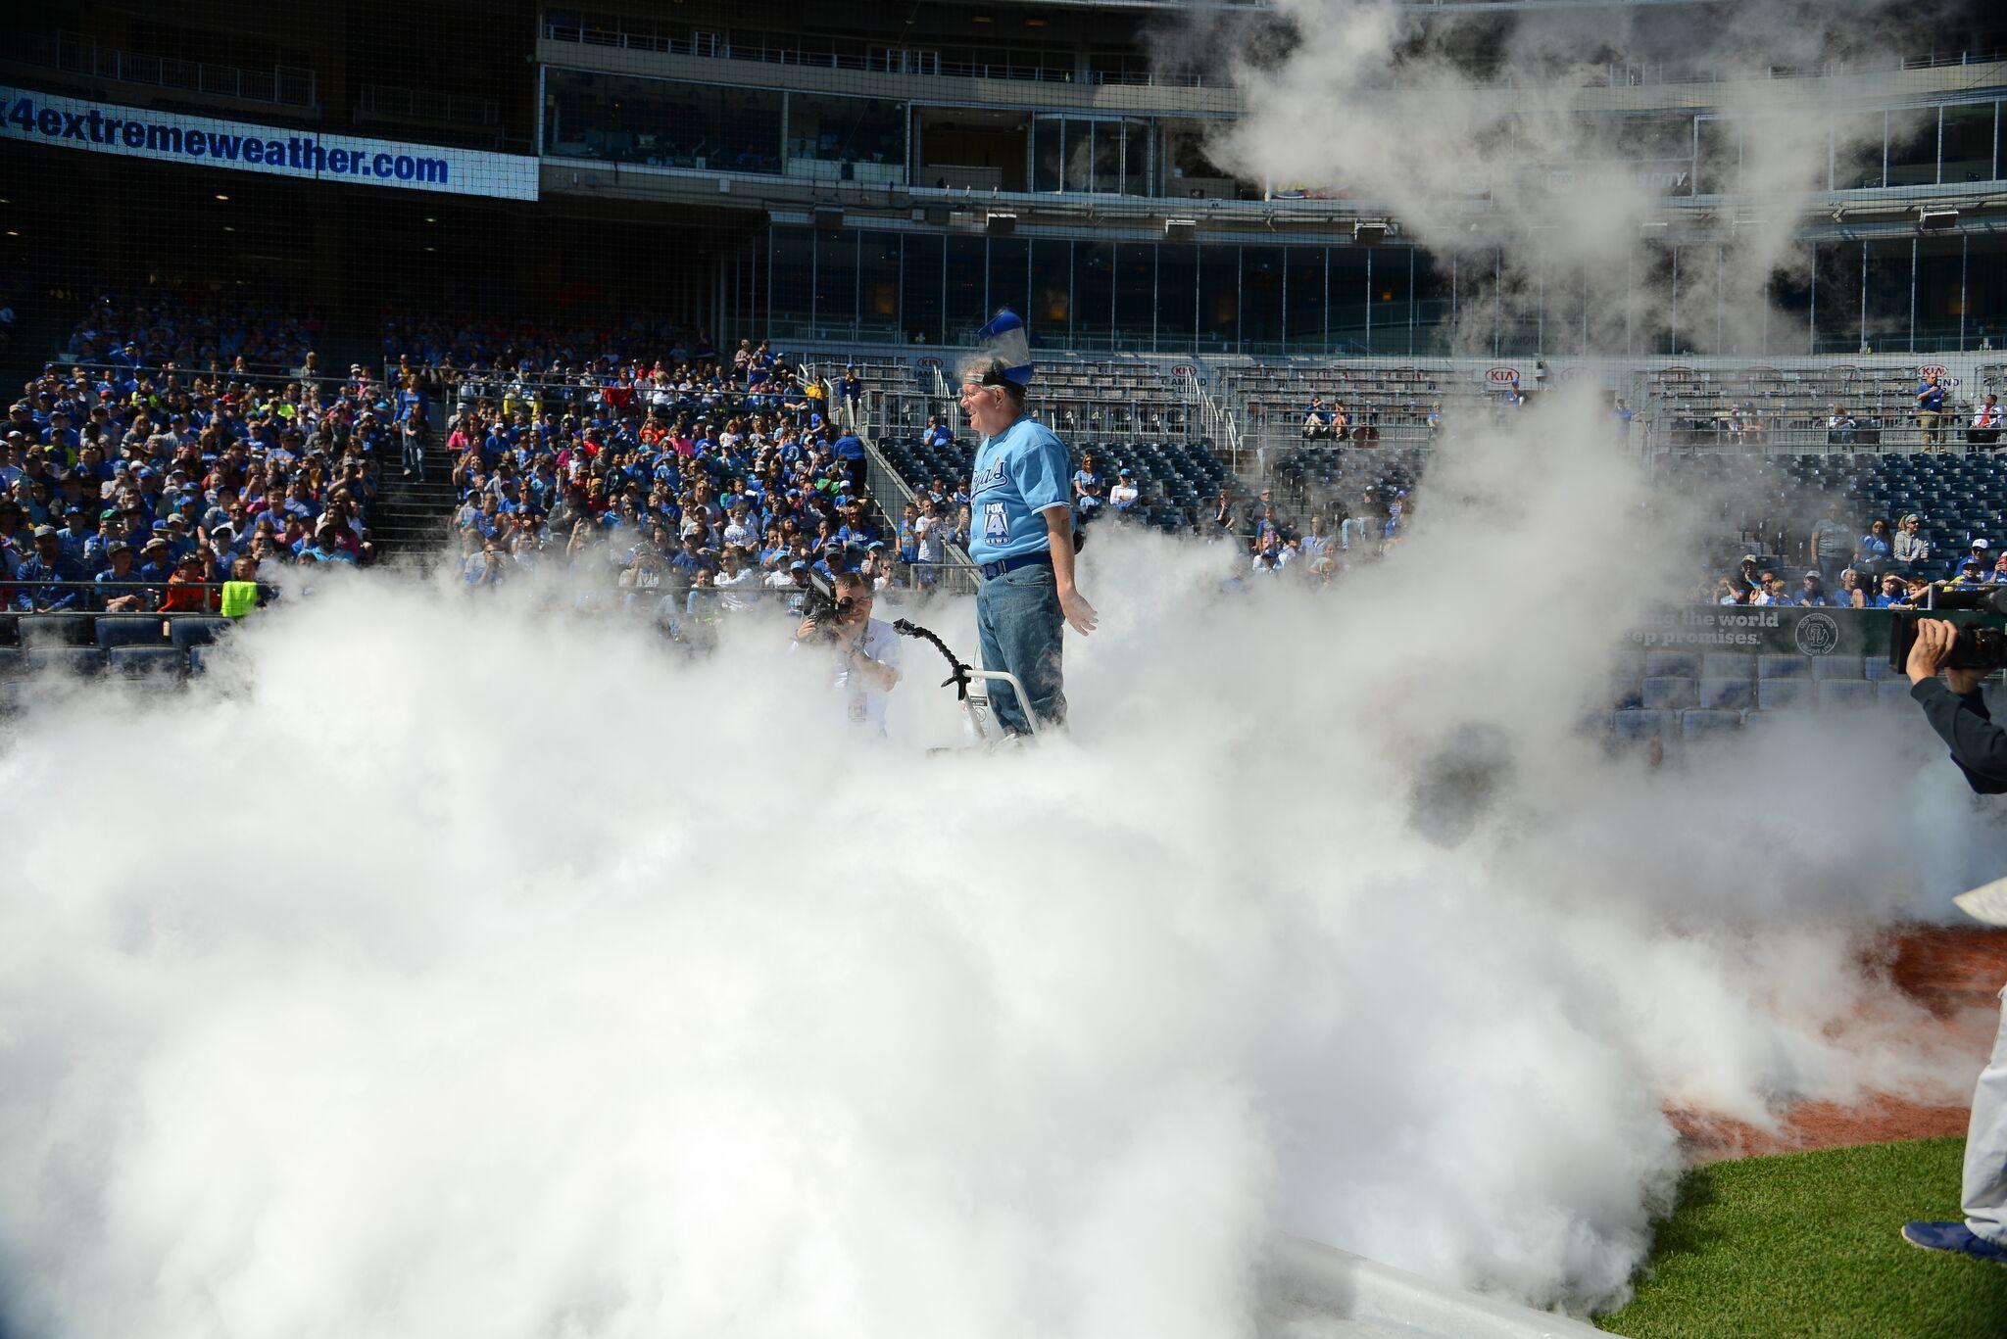
In addition to my on-air work, I created a giant annual outdoor weather show for the Kansas City Royals baseball team, called School Day at the K. For 20 years I wrote and produced that program to use that venue to spark students’ interest in science. Science can be a daunting subject for some students, but I wanted to show them that they were capable of understanding and using science in their lives and perhaps even as a career.
The show was wildly successful. Over the course of 20 years, we educated more than a quarter million students at our shows. I won 6 Emmy Awards for my work on the show, and my experience in sharing my expertise with kids is what led me and my business partner, Tye Murphy, to develop IQ Weather.
We set out to create a course that teaches kids about how our amazing planet really works. Our weather and climate are determined by forces so powerful and enormous that it is truly hard to imagine. Oceans, volcanoes, space dust, solar cycles, other planets in our solar system, and even our location in the galaxy all pay a role in what we experience here on Earth each day. God created an amazingly complex and resilient place for us to call home.
There is so much to know and understand. Your entire family will benefit by looking at the science of weather in a different way. Understanding the various interactions that take place each day which lead to changes in weather patterns, or in long term climate patterns will help your kids realize that simplistic tweets or “sound bite” science is not true science. Our course is designed to give them a strong base of knowledge that will help them filter out deceptive and misleading information they might be exposed to every day from many sources. If you understand how science really works, it is much harder to be fooled!
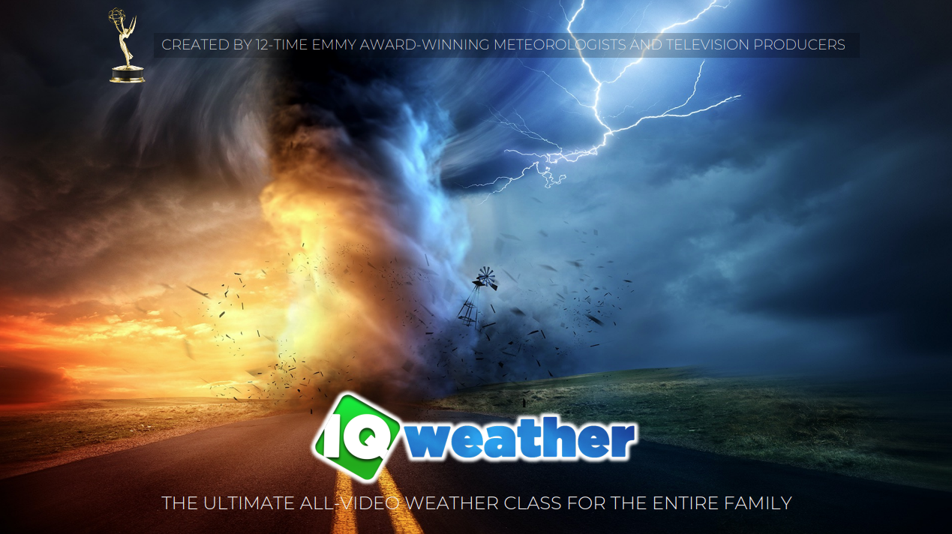
In addition to our video lessons, we also provide quizzes, points to discuss, lesson resources, teaching guides, experiments, and links to extra study resources for a deeper dive on many topics. Our goal was to make a course that offers something for every member of the family, and to make the lessons fun and interesting! We hope you have as much fun taking the course as we’ve had creating and designing it!

