Sourdough Starter
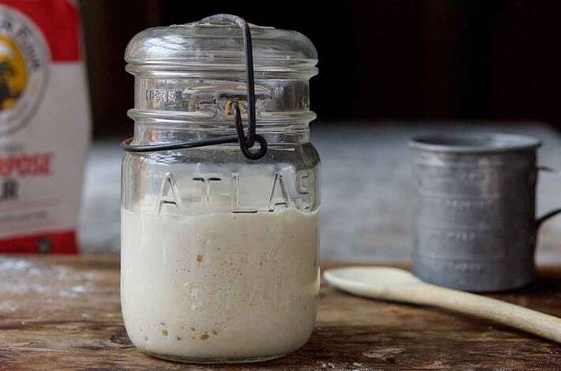

Ingredients
To begin your starter
- 1 cup (113g) whole rye (pumpernickel) or whole wheat flour
- 1/2 cup (113g) cool water*
- scant 1 cup (113g) Unbleached All-Purpose Flour
- 1/2 cup (113g) cool water (if your house is warm), or lukewarm water (if your house is cool)

Instructions
- Day 1: Combine the pumpernickel or whole wheat flour with the cool water in a non-reactive container. Glass, crockery, stainless steel, or food-grade plastic all work fine for this. Make sure the container is large enough to hold your starter as it grows; we recommend at least 1-quart capacity.
- Stir everything together thoroughly; make sure there's no dry flour anywhere. Cover the container loosely and let the mixture sit at warm room temperature (about 70°F) for 24 hours. See "tips," below, for advice about growing starters in a cold house.
- Day 2: You may see no activity at all in the first 24 hours, or you may see a bit of growth or bubbling. Either way, discard half the starter (4 ounces, about 1/2 cup), and add to the remainder a scant 1 cup King Arthur Unbleached All-Purpose Flour, and 1/2 cup cool water (if your house is warm); or lukewarm water (if it's cold).
- Mix well, cover, and let the mixture rest at room temperature for 24 hours.
- Day 3: By the third day, you'll likely see some activity — bubbling; a fresh, fruity aroma, and some evidence of expansion. It's now time to begin two feedings daily, as evenly spaced as your schedule allows. For each feeding, weigh out 4 ounces starter; this will be a generous 1/2 cup, once it's thoroughly stirred down. Discard any remaining starter.
- Add a scant 1 cup (4 ounces) King Arthur Unbleached All-Purpose Flour, and 1/2 cup water to the 4 ounces starter. Mix the starter, flour, and water, cover, and let the mixture rest at room temperature for approximately 12 hours before repeating.
- Day 4: Weigh out 4 ounces starter, and discard any remaining starter. Repeat step #6.
- Day 5: Weigh out 4 ounces starter, and discard any remaining starter. Repeat step #6. By the end of day #5, the starter should have at least doubled in volume. You'll see lots of bubbles; there may be some little "rivulets" on the surface, full of finer bubbles. Also, the starter should have a tangy aroma — pleasingly acidic, but not overpowering. If your starter hasn't risen much and isn't showing lots of bubbles, repeat discarding and feeding every 12 hours on day 6, and day 7, if necessary — as long as it takes to create a vigorous (risen, bubbly) starter. Note: see "tips," below.
- Once the starter is ready, give it one last feeding. Discard all but 4 ounces (a generous 1/2 cup). Feed as usual. Let the starter rest at room temperature for 6 to 8 hours; it should be active, with bubbles breaking the surface. Hate discarding so much starter? See "tips," below.
- Remove however much starter you need for your recipe — typically no more than 8 ounces, about 1 cup. If your recipe calls for more than 1 cup of starter, give it a couple of feedings without discarding, until you've made enough for your recipe plus 4 ounces to keep and feed again.
- Transfer the remaining 4 ounces of starter to its permanent home: a crock, jar, or whatever you'd like to store it in long-term. Feed this reserved starter with 1 cup of flour and 1/2 cup water, and let it rest at room temperature for several hours, to get going, before covering it. If you're storing starter in a screw-top jar, screw the top on loosely rather than airtight.
- Store this starter in the refrigerator, and feed it regularly; we recommend feeding it with a scant 1 cup flour and 1/2 cup water once a week.

Tips from our Bakers
- Why do you need to discard half the starter? It seems so wasteful... But unless you discard starter at some point, eventually you'll end up with a very large container of starter. Also, keeping the volume down offers the yeast more food to eat each time you feed it; it's not fighting with quite so many other little yeast cells to get enough to eat. You don't have to actually discard it if you don't want to, either; you can give it to a friend, or use it to bake. There are quite a few recipes on our site using "discard" starter, including pizza crust, pretzels, and waffles, and even chocolate cake.
- Why does this starter begin with whole-grain flour? Because the wild yeast that gives sourdough starter its life is more likely to be found in the flora- and fauna-rich environment of a whole-grain flour than in all-purpose flour.
- Want to put your starter on hold for the summer, or as you go on vacation? Here's how: Drying your sourdough starter.
- Should you use bottled water? Unless your tap water is so heavily treated that you can smell the chemicals, there's no need to use bottled water; tap water is fine.
- A note about room temperature: the colder the environment, the more slowly your starter will grow. If the normal temperature in your home is below 68°F, we suggest finding a smaller, warmer spot to develop your starter. For instance, try setting the starter atop your water heater, refrigerator, or another appliance that might generate ambient heat. Your turned-off oven — with the light turned on — is also a good choice.
- One of our readers offers the following thoughts about the duration of everyday feeding, which we think is great advice: "Conditions vary so widely that 7 days can be far too little. I've learned the key is to watch for a dramatic and consistent rise in the jar — at least doubling between 1 and 4 hours after feeding. This could be 7 days or less after you begin, or it could be three weeks (for me it was 12 to 14 days). I would encourage you to consider tweaking your wording a bit to guide bakers to watch for this phenomenon, rather than watch the calendar." Thanks, Ken!

Sourdough Starter: Sharing a Sign of Hope

Rehydrate your starter:
Take ¼ tsp powdered or a quarter-sized flake of the starter and place in a clean glass jar. Add 2 TBS of warm water (90-105°F). Let soften and dissolve for a few minutes. Then add 2 TBS of all-purpose flour and stir. Cover loosely and leave at room temperature until small bubbles form (usually a few hours) then feed your starter.
Note: If you like a firmer starter, you can use a 2:1 ratio of flour to water.

Feed your starter:
The secret to feeding your starter is equal parts flour, starter and warm water. By knowing that trick you can make as little or much starter as you need. If you have 3 TBS of starter from the recipe above, add 3 TBS of warm water and 3 TBS of flour and stir. Feed your starter every day if it is sitting on the counter at room temperature. You will need to use it every day or throw some away so you don’t end up with buckets. You can store your starter in the fridge and only feed it once a week. You will need to bring it to room temperature and feed your starter to use it. Starter is ready to use when it is bubbling and active, which can be same day when starting with dehydrated.

Use your starter:
Always begin with a fed, bubbly starter. And don’t use it all up! Keep some in another jar for your next recipe!

Sandwich Bread
1/3 cup active starter
1 ¼ cups warm water
1 TBS oil
3 1/3 cups bread flour
¾ cups all-purpose flour
1 ½ tsp salt
In a large bowl mix starter and warm water. Add flours, salt and oil and knead till bread comes together. If you have a bread machine you can put it on a pizza dough setting and let it do the kneading. Bulk rise overnight or for 8-10 hours. Shape the dough and put in your oiled 9x5 loaf pan and let rise for 1-2 hours again. The warmer your room is the faster it will rise. Bake at 375°F for 40-45mins or when the bread’s internal temperature is 210°F. Cool in pan for 10mins and then turn out and cool completely.

Pancakes
½ cup active starter
1 cup flour
1 cup warm water or milk
1 egg
½ tsp of salt
Mix all ingredients together and let sit for 10-20mins or you can mix the first three ingredients the night before and add the latter two in the morning with no wait time. Cook on a hot griddle. Makes about 6 pancakes.

Tortillas
3 cups flour
3 cups warm water
½ cup active starter
Mix all ingredients together and let ferment 6-10 hours or overnight. Then add a heaping tsp of salt and 1-2 TBS oil. Pour onto a very hot griddle and spread into a thin circle. Makes about 12 tortillas.

Share it:
To dehydrate and share your starter simply take your fed starter and spread a thin layer on a piece of wax paper with a cookie sheet underneath. Leave on the counter to dry for 12-36 hours. It peels away from the wax paper as it dries. Store in an airtight container. Put in baggies and include a copy of these instructions for others to enjoy making bread without industrial yeast. Keep some for yourself for when you accidentally cook with all your starter!

Great book for more recipes and information: “Artisan Sourdough Made Simple” by Emilie Raffa.

“I am the bread of life; whoever comes to me shall not hunger...” John 6:35

Take it. Make it. Share it.

Sourdough Pretzels

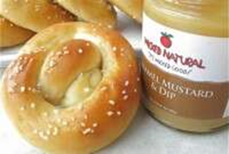

Ingredients
Pretzels
- 3/4 cup + 2 tablespoons (198g) water
- 1 cup (227g) sourdough starter, unfed/discard
- 3 cups (361g) King Arthur Unbleached Bread Flour
- 1/4 cup (28g) Baker's Special Dry Milk or nonfat dry milk
- 1 tablespoon (14g) sugar or 2 tablespoons (14g) non-diastatic malt powder
- 1 tablespoon butter or vegetable oil
- 1 1/2 teaspoons salt
- 2 teaspoons instant yeast
Topping
- 1 tablespoon sugar or non-diastatic malt powder
- 2 tablespoons (28g) water
- pretzel salt
- 2 tablespoons (28g) melted butter, optional

Instructions
- Prepare a baking sheet by spraying it with vegetable oil spray, or lining it with parchment paper. If you're not using King Arthur Flour's brand, grease the parchment with vegetable oil spray to make double-sure the pretzels won't stick.
- Mix and knead the dough ingredients — by hand, mixer, or bread machine — to make a cohesive, fairly smooth dough. It should be slightly sticky; if it seems dry, knead in an additional tablespoon or two of water.
- Cover the dough and let it rest for 45 minutes. It will rise minimally. Towards the end of the rising time, preheat the oven to 350°F.
- Turn the dough out onto a lightly greased work surface, fold it over a few times to gently deflate it, then divide it into 12 pieces, each weighing about 2 1/4 to 2 1/2 ounces.
- Roll each piece of dough into an 18" rope. Shape each rope into a pretzel.
- Dissolve the malt in the water. Brush the pretzels with the solution, and sprinkle lightly with coarse pretzel salt.
- Bake the pretzels for 25 to 30 minutes, until they're a light golden brown. Note: This is correct; there's no need to let the shaped pretzels rise before baking.
- Remove the pretzels from the oven, and brush with melted butter, if desired.

Tips from our Bakers
- Don’t have any starter? Here’s a recipe for homemade sourdough starter. If you're making it from scratch, you'll need to feed it for 5 to 7 days before it’s ready for baking. Want a head start? Purchase our classic fresh sourdough starter – it’ll be ready for baking soon after it arrives at your door. Looking for tips, techniques, and all kinds of great information about sourdough baking? Find what you need in our sourdough baking guide.
- Want to make your pretzels even chewier? Substitute our high-gluten flour in place of the bread flour called for; no additional changes are necessary.

Sourdough Pancakes
Ingredients
- 1/2 cup sourdough starter (use discard if you want)
- 1 cup whole milk
- 1 1/4 cups all-purpose flour
- 2 large eggs, beaten
- 2 tablespoons granulated sugar
- 1 teaspoon baking powder
- 1/2 teaspoon salt
- 2 tablespoons butter, melted and cooled
- 1/2 teaspoon vanilla extract
- Neutral oil, such as vegetable or canola oil (or butter), for greasing the pan or griddle
- Berries, garnish
- Maple syrup, garnish
- Powdered sugar, garnish
- Melted butter, garnish
Directions
- Combine the sourdough starter with the milk and flour in a large bowl that is big enough to allow the mixture to rise.
- Mix pancake batter
- Cover the bowl with plastic wrap and leave it on the counter overnight; the batter needs to rise and continue to develop its sourdough flavor. This will be your overnight sponge and the base for the pancakes.
- Let the pancake batter rest
- In the morning, add the beaten eggs, sugar, baking powder, and salt to the sourdough starter mixture. Whisk until combined and smooth.
- Add in the eggs
- Whisk in the cooled melted butter and the vanilla extract. The batter will be very thick and almost like a slack bread dough after you are done mixing.
- Whisk the batter
- Heat up a cast-iron skillet or griddle over medium-high heat and add a little bit of neutral oil or butter. Turn the heat down to medium-low and ladle 1/4 cup batter to the skillet. Cook for a few minutes until bubbles start forming on top and the pancakes are browned on the underside.
- Cook pancakes on a cast-iron pan
- Flip the pancakes over and cook for another minute on the other side. It doesn't take as long on the second side, so watch carefully. Repeat with the remaining batter.
- Cooked sourdough pancake
- Serve the pancakes with fresh berries, maple syrup, powdered sugar, and/or melted butter.
Tips
- Make sure the melted butter is completely cooled (but still liquid) before adding it to the batter. If warm butter combines with cold ingredients, it will solidify into clumps.
- If you use a griddle, you can cook several pancakes at a time. Nonstick surfaces are best for cooking pancakes.
- It's important to keep the heat low while cooking these pancakes. Because the batter is thicker, these pancakes take more time to cook through than typical recipes. If the heat is too high, the pancakes can burn on the outside while remaining uncooked on the inside.
Sourdough Crumpets
Ingredients
- 1 cup (227g) sourdough starter, unfed/discard
- 1 teaspoon granulated sugar
- 1/4 to 1/2 teaspoon salt
- 3/8 teaspoon baking soda*
*If your discard starter is particularly sour, increase the baking soda to 1/2 teaspoon.
Instructions
- Place the starter in a medium-sized bowl. Stir in the sugar and salt, then the baking soda. The batter should rise up and bubble a bit, becoming almost billowy.
- Heat your griddle over medium-low heat; 300°F is perfect. Lightly grease the surface with cooking oil (if your pan isn't non-stick), then melt a pat of butter atop the oil.
- Lightly grease four English muffin rings (1" high and 4" across) and place on the griddle. Divide the batter evenly among the rings. Each ring will take a generous 1/4 cup of batter; a generously heaped muffin scoop is the perfect tool for this task. Cook for about 5 minutes, until the tops are set and full of small holes. Carefully flip the crumpets over, remove the rings (they should pop right off), and continue to cook for about 3 minutes, until they're golden on the bottom.
- Enjoy the crumpets warm, split and spread with butter and jam. Or toast to brown and crisp them before serving.
- Store any leftovers at room temperature for several days. Freeze, well wrapped, for longer storage.
Tips from our Bakers
- Don’t have any starter? Here’s a recipe for homemade sourdough starter. If you're making it from scratch, you'll need to feed it for 5 to 7 days before it’s ready for baking. Want a head start? Purchase our classic fresh sourdough starter – it’ll be ready for baking soon after it arrives at your door. Looking for tips, techniques, and all kinds of great information about sourdough baking? Find what you need in our sourdough baking guide.
- Don't have English muffin rings (or suitably sized canning jar lids)? Instead of crumpets, make pikelets. Griddled free-form (so they're flatter) and with fewer holes than a typical English crumpet, Australian-style pikelets are a kind of "toaster pancake," perfect for toasting and spreading with butter and jam.
- Join pastry chef Gesine Bullock-Prado as she demonstrates how to make Sourdough Crumpets from start to finish. Watch Episode 3 of the Isolation Baking Show now.
- Taking the pancake idea one step further, the flavor of these crumpets or pancakes, while quite delicious with butter, syrup or jam, is equally good with savory additions. Try adding a half cup each of grated zucchini, cheese, apple, chives, or onion, or a combination of your own, and serve them with lunch or dinner.

Sourdough Cinnamon Crumb Cake

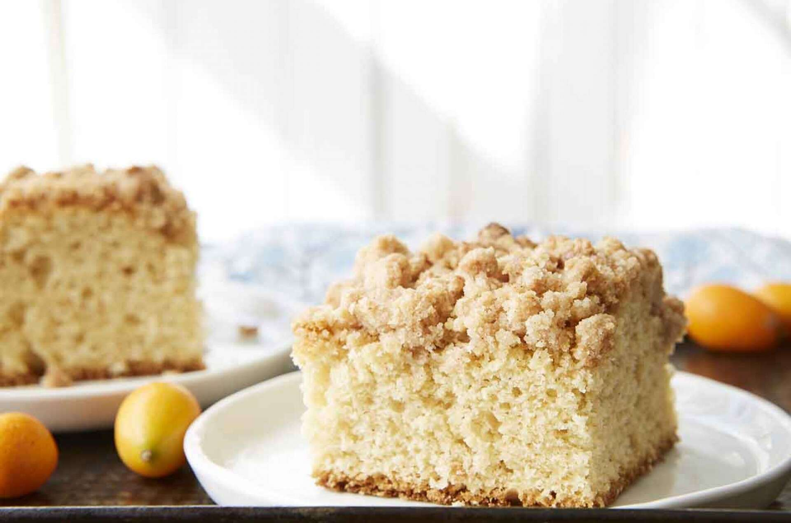

Ingredients
Topping
- 2 cups (241g) King Arthur Unbleached All-Purpose Flour
- 1 cup (198g) granulated sugar
- 1 1/2 teaspoons cinnamon
- 1/2 teaspoon salt
- 1 teaspoon vanilla extract
- 1/2 teaspoon almond extract
- 12 tablespoons (170g) unsalted butter, melted
Batter
- 8 tablespoons (113g) unsalted butter, at room temperature, at least 65°F
- 1 cup (198g) granulated sugar
- 2 large eggs, at room temperature
- 1 tablespoon vanilla extract
- 1 cup (227g) sourdough starter, unfed/discard
- 2 cups (241g) King Arthur Unbleached All-Purpose Flour
- 1 tablespoon potato flour or 2 tablespoons instant mashed potato flakes
- 1 teaspoon baking powder
- 1/2 teaspoon baking soda
- 1/2 teaspoon salt
- 1/4 cup (57g) milk, at room temperature
- confectioners' sugar, optional

Instructions
- Preheat the oven to 350°F. Grease a 9" square pan.
- To make the topping: In a medium bowl, whisk together the flour, sugar, cinnamon, and salt. Add the vanilla and almond extracts to the melted butter and pour the butter into the flour mixture, stirring until you have a uniformly moist mixture. Set aside while you make the batter.
- To make the batter: In a large mixing bowl, beat the butter and sugar until well combined. Add the eggs, vanilla, and starter, mixing until smooth and scraping the bowl's sides and bottom as you go.
- In a medium bowl, whisk together the all-purpose flour, potato flour, baking soda, salt, and baking powder. Add to the butter/starter mixture, stirring until evenly combined. Add the milk and mix until smooth.
- Spread the batter in the prepared pan. Sprinkle the crumb mixture evenly over the top.
- Bake the cake for 45 to 50 minutes, until a paring knife inserted in the center comes out clean, and the edge of the cake just barely pulls away from the pan. Remove it from the oven and cool on a rack; dust the top with confectioners' sugar if desired.
- Store the cake, the pan covered with plastic, at room temperature for several days; freeze for longer storage.

Tips from our Bakers
- Don’t have any starter? Here’s a recipe for homemade sourdough starter. If you're making it from scratch, you'll need to feed it for 5 to 7 days before it’s ready for baking. Want a head start? Purchase our classic fresh sourdough starter – it’ll be ready for baking soon after it arrives at your door. Looking for tips, techniques, and all kinds of great information about sourdough baking? Find what you need in our sourdough baking guide.
- Some bakers have commented on the "overly generous" amount of crumb topping. After re-testing just to make sure, we stand by the amount of topping as written: enough to cover the cake generously, without leaving any bare spots. If desired, reduce the topping ingredient amounts by 25 percent.

No-Knead Sourdough Bread
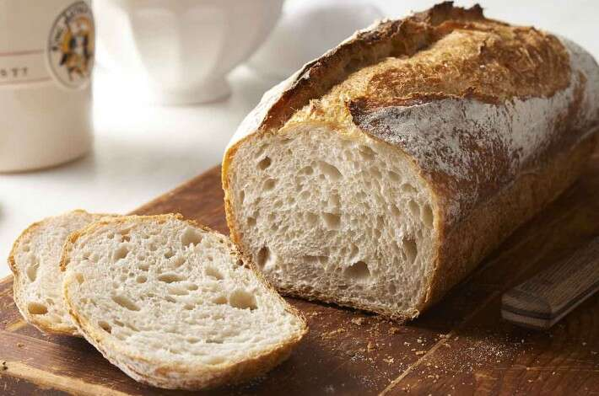
Ingredients
- 1 cup (227g) ripe (fed) sourdough starter
- 1 3/4 cups (397g) lukewarm water
- 5 cups (602g) Unbleached Bread Flour
- 1 tablespoon (18g) salt
- 2 teaspoons diastatic malt powder, optional for a more golden color and stronger rise
Instructions
- Weigh your flour; or measure it by gently spooning it into a cup, then sweeping off any excess.
- Combine all the ingredients in a large mixing bowl, or a large (6-quart) food-safe plastic bucket.
- Mix and stir everything together to make a sticky, rough dough. If you have a stand mixer, beat at medium speed with the paddle attachment for 30 to 60 seconds. If you don't have a mixer, just stir with a big spoon or dough whisk until everything is combined.
- Leave the dough in the bucket or 6-quart bowl, cover it with the bucket’s lid or a piece of plastic wrap, and let it rise for 1 hour.
- Gently pick up the dough and fold it over on itself several times, cover it again, and let it rise for another hour.
- Repeat the rising-folding process one more time (for a total of 3 hours), folding it again after the last hour. Then, place the bucket or bowl in the refrigerator, and let the dough rest for at least 8 hours (or up to 48 hours).
- When you're ready to make bread, turn the dough out onto a well-floured work surface, and shape it into a rough ball. Leave the dough seam-side up, cover it, and let it rest on a floured surface for 15 minutes.
- Next, shape the dough to fit the vessel in which you’ll bake it: a 13” log for a long covered baker, such as a glazed long covered baker; or a large boule (round) for a round baker or Dutch oven. Place the shaped dough into the lightly-greased or semolina-dusted base of the baker and cover it with the lid.
- Let the loaf warm to room temperature and rise; this should take about 2 1/2 to 3 hours. It won't appear to rise upwards that much, but will relax and expand.
- With a rack positioned in the middle, start preheating the oven to 500°F one hour before you’re ready to bake.
- Just before baking, dust the loaf with a fine coat of flour and use a lame or a sharp knife to make one or several 1/2” deep slashes through its top surface. If you're baking a long loaf, one arched slash down the loaf lengthwise is nice, or if baking a round, a crosshatch or crisscross pattern works well.
- Cover the baker with its lid and place it in the oven. Reduce the oven temperature to 450°F and bake the bread for 45 minutes.
- Remove the cover of the baker and bake the bread for 10 to 15 minutes longer, until the bread is deep golden brown and crusty, and a digital thermometer inserted into the center of the loaf reads at least 210°F.
- Remove the bread from the oven and transfer it to a rack to cool completely.
- Store leftover bread in a plastic bag at room temperature for several days; freeze for longer storage.

How to Grow a Kombucha Scoby from Bottled Kombucha - Ditch the Wheat
How to Make Sourdough Starter From Scratch | Easy Baking Tips and Recipes: Cookies, Breads & Pastries : Food Network | Food Network
Little Spoon Farm | Sourdough Baking and Comfort Food Recipes

Putting your sourdough starter on hold

1. Ready your sourdough starter for storage.
First, feed your starter as though you were going to bake with it. If it's been stored in the fridge, take it out, and feed it with equal parts unbleached all-purpose flour and lukewarm water. Let it rest, covered, until it becomes very bubbly and healthy looking.
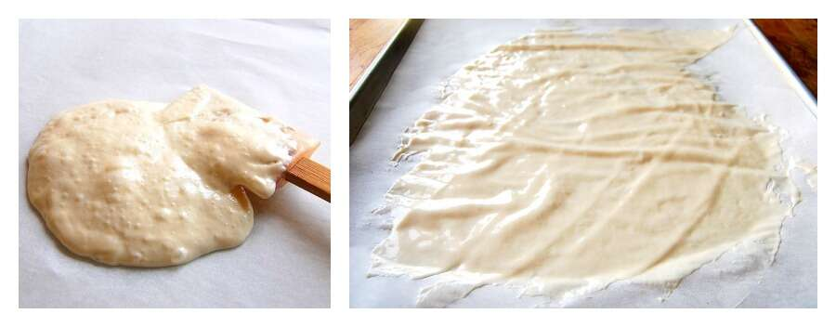

2. Spread it out to dry.
Next, spread it – all of it* – onto two pieces of parchment. It helps to set each piece of parchment on a baking sheet, simply for ease of transportation.
The starter should be spread as thinly as possible; use a spatula, an offset spatula, or a bowl scraper to help the process along.
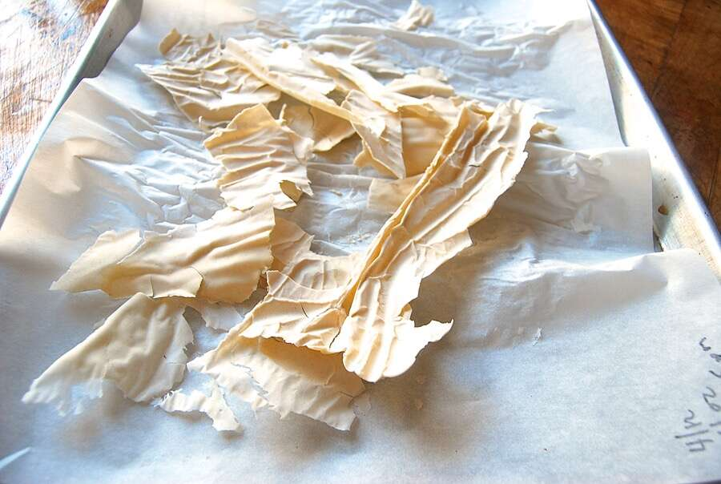

3. Dry the starter completely, until it's brittle.
Let the starter dry at room temperature until it's completely and utterly dry. This will take a day (if you live, say, in Arizona, in a house without air conditioning); or up to three, four, five days – it totally depends on the weather. In Seattle, in winter? Count on a long dry.
If you live somewhere humid, can you dry your starter in the oven? Yes; but be careful. Rather than turning the oven on to warm it, I'd advise using only your oven's electric light, which will produce very gentle, even heat. You don't want to risk turning the oven on and accidentally making it too hot, which would kill your starter. (See step #8, below.)
Completely dry starter should peel easily off the parchment; when you pick a piece up, it will be brittle and easily snap between your fingers. If you have a scale, weigh it; if you started with 4 ounces starter on your parchment, it should weigh 2 ounces (or very close) when it's completely dry.

4. Break it into pieces.
Break the starter into small chips with your hands; or place it in a plastic bag and pulverize it with something heavy.
Can you run it through a food processor? Yes, but it's not necessary; just break it into chips as best you can.
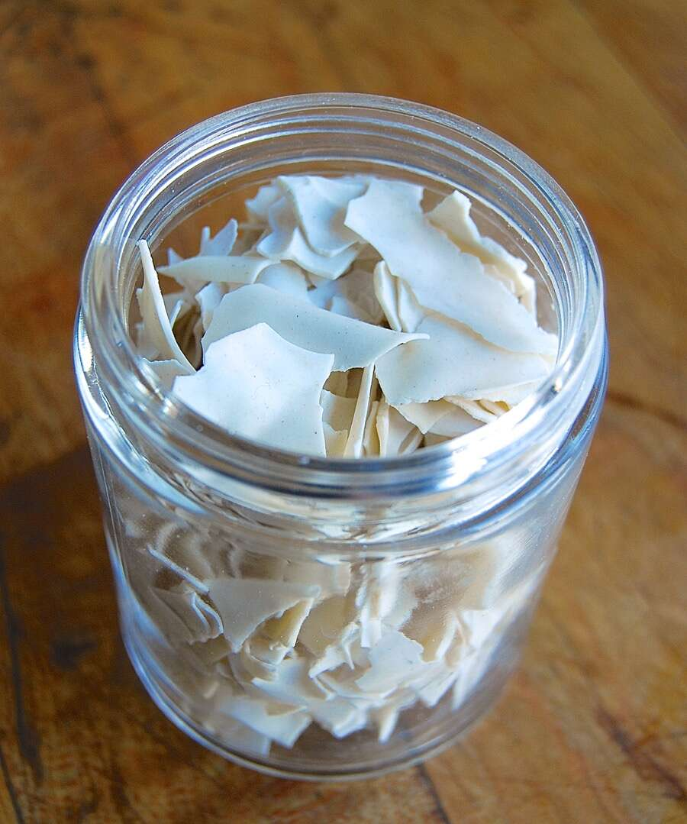

5. Store it airtight.
Store the starter airtight, preferably in a glass container. You want something totally inert, with an airtight cover; a glass jar is perfect. Date the jar and label it; you don't want someone throwing it away during the course of some pantry spring cleaning.
Keep the jar of dried starter in a cool, dark place, if possible. Not cool as in refrigerator; just not sitting in the hot sun, or over your woodstove. Be sensible.

6. Bring your sourdough starter back to life.
When you're ready to revive the starter, measure out 1 ounce (or about 1/8 of it, if you'd been following a regular feeding pattern and had about 8 ounces starter on hand at the beginning of the drying process).
Don't have a scale? Well, depending on the size of your chips, this will be between 1/4 and 1/3 cup.
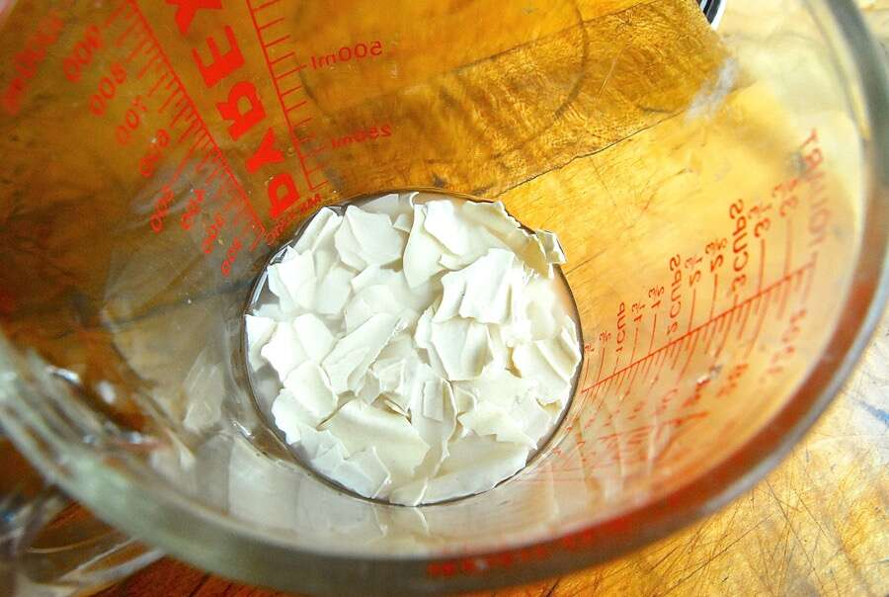

7. Mix the starter with lukewarm water.
Place the dried starter chips in a large (at least 1-pint) container. Add 2 ounces (1/4 cup) of lukewarm water. The water should barely cover the chips; tamp them down, if necessary.
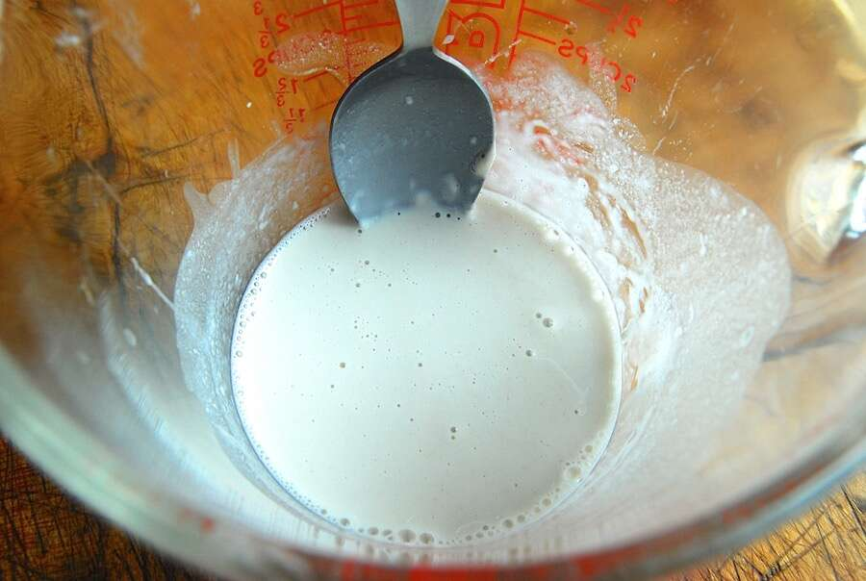
Stir the chips/water occasionally; it'll take 3 hours or so, with infrequent attention, to dissolve the chips.
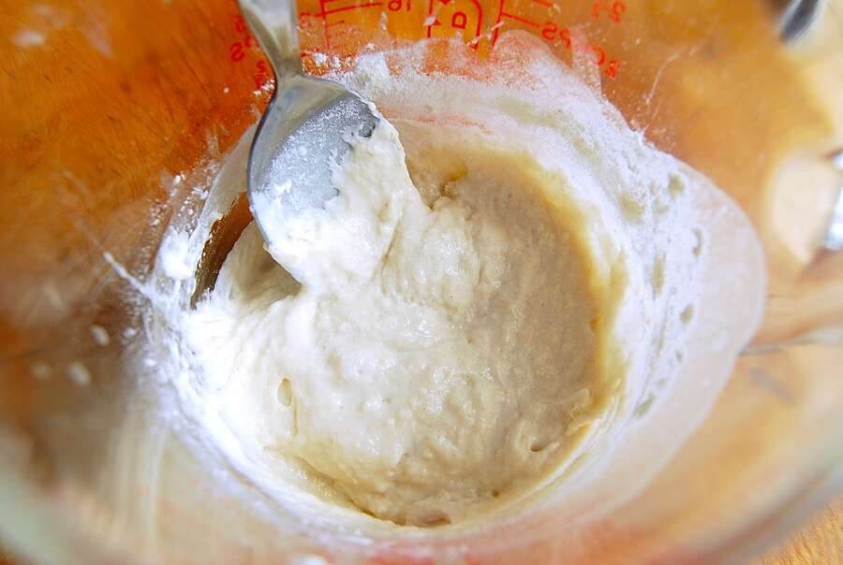

8. Feed it with flour.
Once the mixture is fairly smooth/liquid, with perhaps just a couple of small undissolved chips, feed it with 1 ounce (about 1/4 cup) of unbleached all-purpose flour. Cover it lightly (a shower cap works well here), and place it somewhere warm.
I like to use my electric oven with the light turned on. Even without ever turning on the heat, it holds a constant temperature between 85°F and 90°F.
You can certainly keep your starter out of the oven, at room temperature; just understand that this whole process, as I'll describe it, will take longer. The cooler the room, the longer it takes sourdough starter to work.
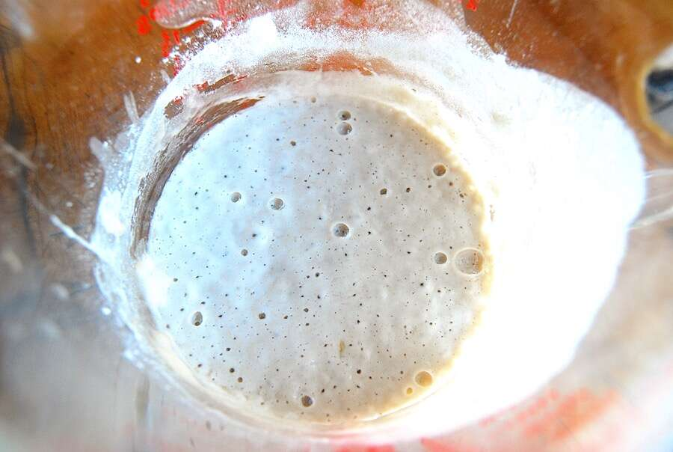

9. Let it rest somewhere warm until it bubbles.
Let the starter work for 24 hours. At the end of that time, you should see some bubbles starting to form. Remember, this is at about 85°F; if your temperature is lower, this will take longer.
How much longer? Totally depends on temperature. Once you do this process once – in your kitchen, in your climate, accounting for your weather – you'll have a better idea.
Sourdough isn't one of those things you can be all engineering about. Forget your timer; just wait until your starter looks like the picture above.

10. Feed the starter again.
WITHOUT DISCARDING ANY OF THE STARTER, feed it with 1 ounce of lukewarm water, and 1 ounce of flour. Cover, and put back in its warm spot. After "X" hours (depends on your kitchen), you should see some serious bubbling; mine took eight hours to become nice and bubbly.

11. And again.
Feed the starter again – 1 ounce of lukewarm water, 1 ounce of flour – cover, and wait. Again, you're not discarding any at this point.
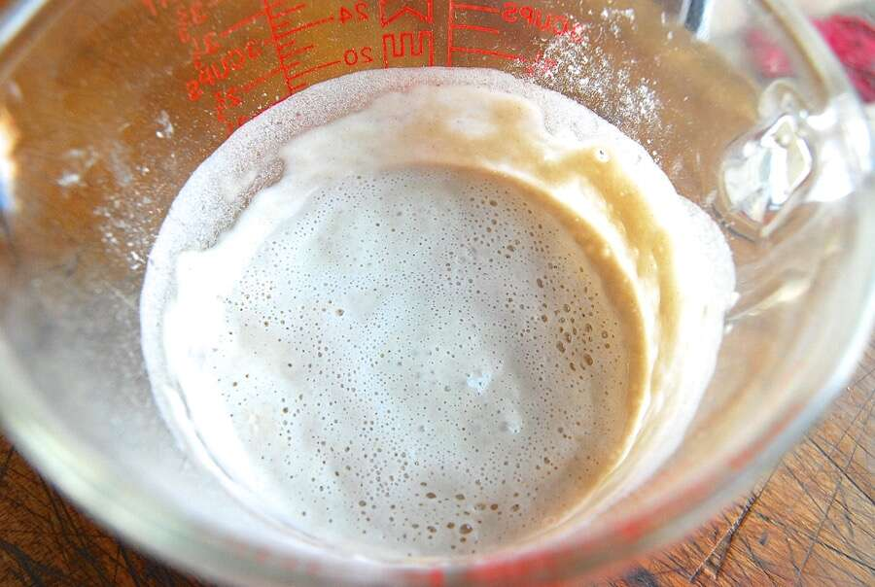
Here's my starter 12 hours later. It's exhibiting a host of tiny bubbles, and has expanded. You may also notice, from the side of the container, that it's risen, and then fallen; this is completely natural.
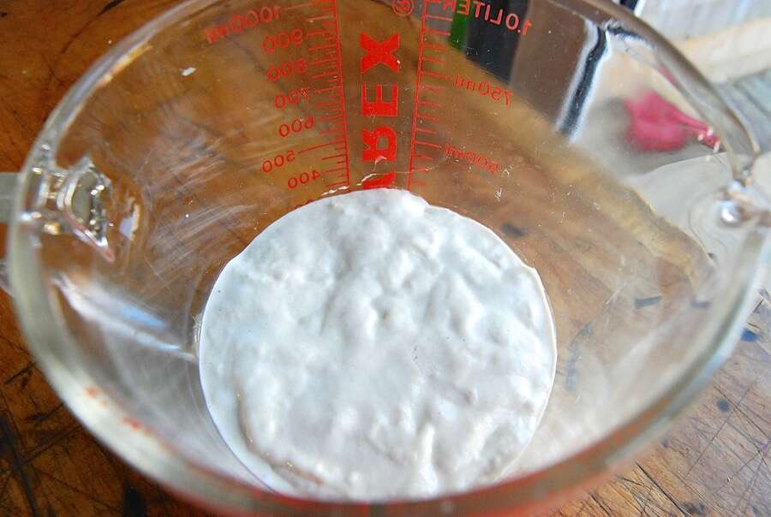

12. Put the starter back on its regular feeding schedule.
Your starter is ready to return to its former life – and its regular schedule. DISCARD all but 4 ounces (about 1/2 cup). Feed it again, this time with 4 ounces each lukewarm water and flour. (That's 1/2 cup of water, and 1 cup of flour, for those of you without a scale. Tell me again why you don't have a scale?)
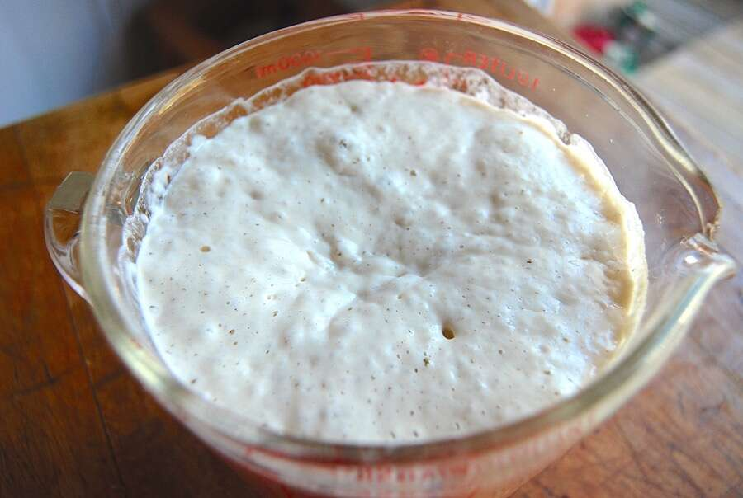
This time, it should really expand quickly. In my 85°F oven, it took just 4 hours for it to triple in size. Your starter is now revived and healthy.

13. At last – you're ready to bake!
To ready the starter for baking (while saving enough for another day), feed it again. Discard all but 4 ounces; and feed the remainder with 4 ounces each lukewarm water and flour. Let it become bubbly – and let the baking begin!
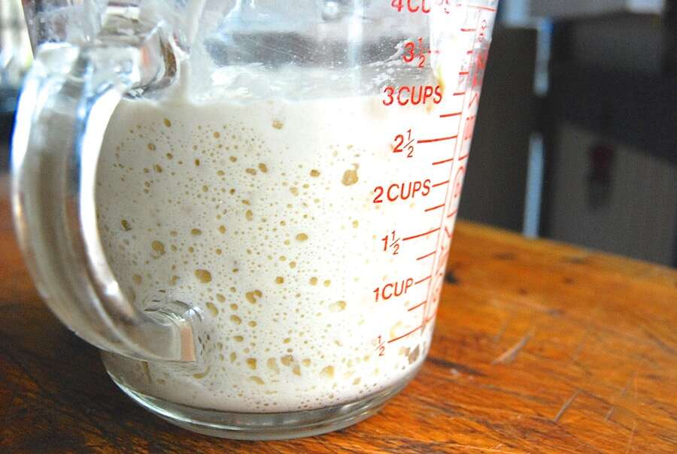

Finally, because I know you'll ask –
Q. Do you have to dry all of your starter?
A. No. Store half in the fridge, if you like. Just don't store any in the freezer; freezing will kill your starter (more on that in a future post).
Q. If you dried all of your starter, and you only revive 1 ounce of it – what do you do with the rest?
A. Give some to a friend (with a link to this blog post, of course). Or just save the rest for sometime in the future.
Q. How long will dried starter stay good?
A. Not sure, but we've heard cases of dried starter remaining viable for over a decade. Thorough drying should preserve your starter indefinitely – just ask King Tut!
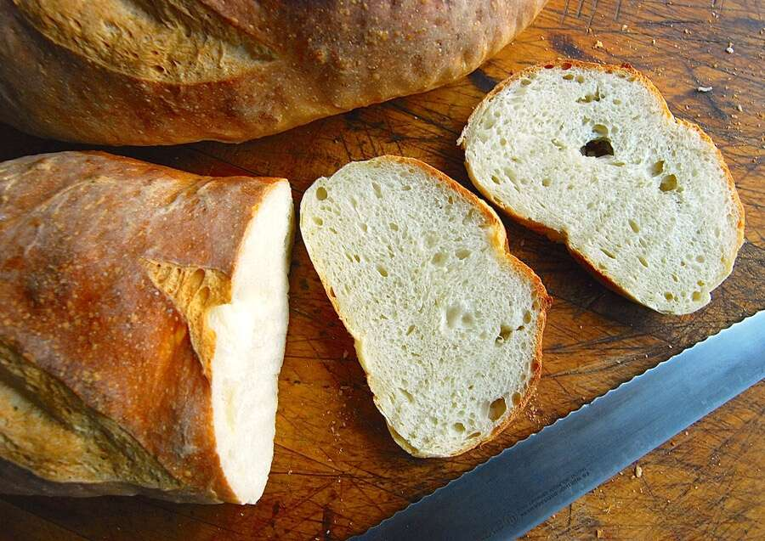
Finally, I couldn't possibly end this post without showing you what happened to my dried, revived, fed, and baked-with starter. This Extra-Tangy Sourdough Bread has NO commercial yeast; it was entirely leavened with my reconstituted starter. Success!

Buttery Sourdough Sandwich Biscuits

Ingredients
- 1 cup (120g) King Arthur Unbleached All-Purpose Flour
- 2 teaspoons baking powder
- 3/4 teaspoon salt
- 8 tablespoons (113g) unsalted butter, cold
- 1 cup (227g) sourdough starter, unfed/discard*

Instructions
- Preheat the oven to 425°F, with a rack in the upper third. Grease a baking sheet, or line it with parchment.
- Combine the flour, baking powder, and salt. Work the butter into the flour until the mixture is unevenly crumbly.
- Add the starter, mixing gently until the dough is cohesive.
- Turn the dough out onto a lightly floured surface (a piece of parchment works well), and gently pat it into a 6" round about 1"-thick.
- Use a sharp 2 3/8" biscuit cutter to cut four rounds, cutting them as close to one another as possible. Gently push and pat the scraps into a 2 1/2" x 5" rectangle. Cut two more biscuits. Push and pat the remaining scraps into a 1"-thick biscuit; it'll be slightly smaller than the others.
- Place the biscuits onto the prepared baking sheet, leaving about 2" between them; they'll spread as they bake.
- Bake the biscuits in the upper third of your oven for 20 to 23 minutes, until they're golden brown.
- Remove the biscuits from the oven, and serve warm. Or cool completely, wrap in plastic, and store at room temperature for several days. Freeze, well-wrapped, for longer storage.

Tips from our Bakers
- Don’t have any starter? Here’s a recipe for homemade sourdough starter. If you're making it from scratch, you'll need to feed it for 5 to 7 days before it’s ready for baking. Want a head start? Purchase our classic fresh sourdough starter – it’ll be ready for baking soon after it arrives at your door. Looking for tips, techniques, and all kinds of great information about sourdough baking? Find what you need in our sourdough baking guide.
- Feel free to make smaller biscuits, if desired; they'll need slightly less time in the oven than the larger biscuits.
- Sourdough starters can vary in how liquid they are. If your biscuit dough seems very dry, dribble in a bit of milk or buttermilk until it comes together.

Baker's Grain Sourdough Bread
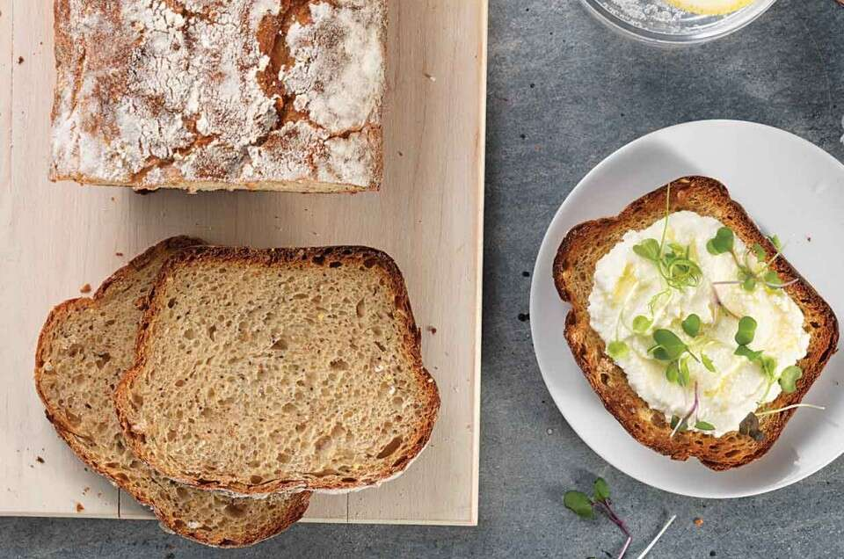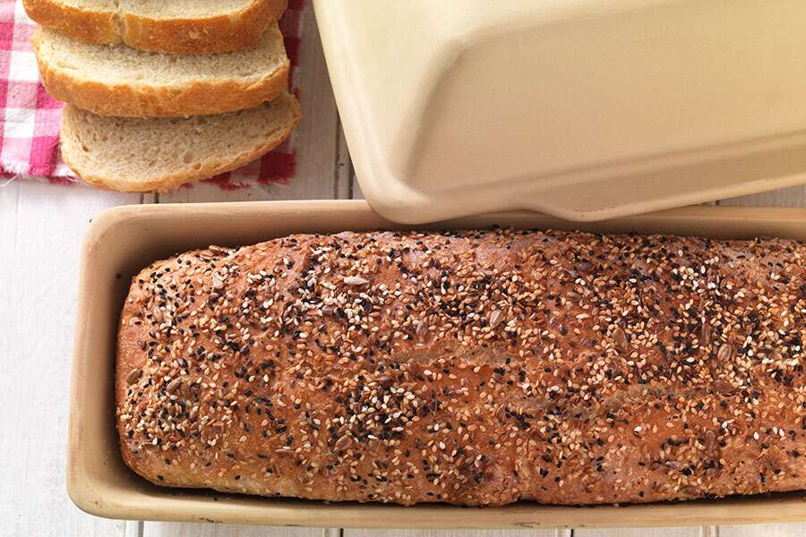

Ingredients
- 1 cup (227g) sourdough starter, ripe (fed) or discard
- 1 cup (227g) lukewarm water
- 2 tablespoons (25g) vegetable oil
- 2 tablespoons (43g) honey
- 2 teaspoons salt
- 2 1/4 cups (269g) High-Gluten Flour
- 1/2 cup (57g) King Arthur Premium 100% Whole Wheat Flour
- 1/2 cup (85g) potato flour or 1 cup (85g) dried potato flakes
- 1/2 cup (74g) Harvest Grains Blend
- 2 teaspoons instant yeast

Instructions
- Mix and knead all the ingredients — by hand, mixer, or bread machine — to form a smooth, elastic dough. The dough will be a little bit sticky; but if it's firm enough to hold its shape, no more flour is necessary.
- Cover the dough and allow it to rise for 1 to 2 hours (depending on the vigor of your starter), until noticeably puffy, though not doubled in bulk.
- Lightly grease and lightly flour the base pan of a long covered baker (glazed or stoneware) or 4 to 4 1/2-quart baking crock or Dutch oven or form the dough into a log and place it on a greased or parchment-lined baking sheet.
- Gently deflate the risen dough and shape it into a log. Place it in the baker, put the lid on, and allow it to rise until it's level with the rim of the glazed baker or 1" over the rim of the stoneware baker, about 1 to 2 hours. Towards the end of the rising time, preheat the oven to 350°F.
- Bake the bread for 35 to 40 minutes with the lid on, then remove the lid and bake for 5 to 10 minutes longer, until the bread is golden brown and the interior registers 190°F on a digital thermometer. Remove the bread from the oven, and turn it out of the pan onto a rack to cool.

Adding sourdough to a recipe
"I really hate throwing away some of my sourdough starter when I feed it. Isn't there something else I can do with it, instead of just ditching it?"
Absolutely. Adding sourdough to a recipe is simpler than you might think – so long as you choose the right recipe, and understand how to do it.
First off, let's get past the romance of sourdough starter – its history, the way it bubbles and grows, its "geographic" range of flavors – and get down to basics. Sourdough starter is equal parts (by weight) flour and water/alcohol, with a bit of organic acids, friendly bacteria, and yeast thrown in.
Why alcohol? Because as the starter ferments, yeast gives off tiny bits of alcohol (in addition to those flavorful organic acids).
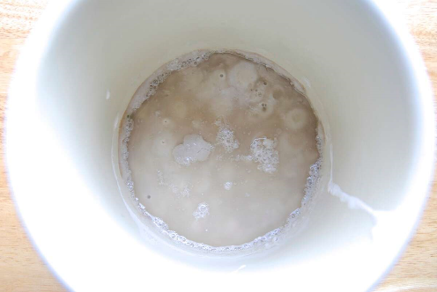
Over the course of time, your starter will gradually become slightly more liquid, due to the addition of this alcohol. That dark liquid you see in the photo above is alcohol sitting atop a starter that hasn't been fed in a couple of weeks.
However, despite this little bit of alcohol, you can continue to think of your starter as equal parts liquid/flour, by weight.
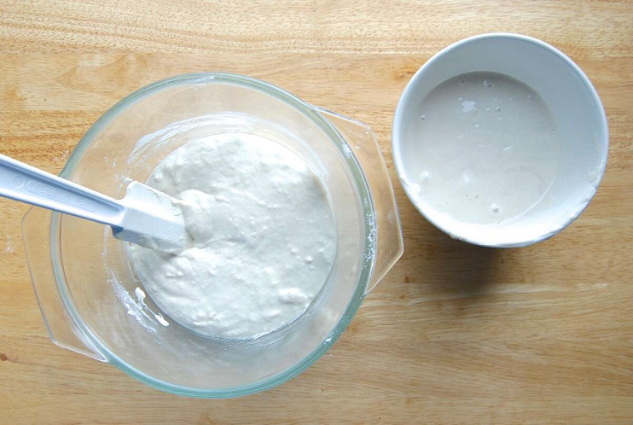
I've just fed my starter (left); on the right is my discard, which measures a scant 1 cup (7 ounces).

What can I do with discard starter?
First, you can use it in any of our online recipes calling for unfed starter.
Beyond that, think of recipes in your own repertoire using flour and water. Or flour and another liquid, like milk or coffee or juice.
And by liquid, I mean liquid that doesn't contribute additional attributes to the baked good's texture, e.g., vegetable oil, which is mainly fat; or honey, which is mainly sugar. Don't substitute sourdough starter for liquid sweeteners or liquid fats.

Adding sourdough to a recipe for cake.
Let's try this unfed starter in one of my favorite cake recipes, King Arthur Flour's Original Cake Pan Cake – which happens to be our 225th anniversary Recipe of the Centuries.
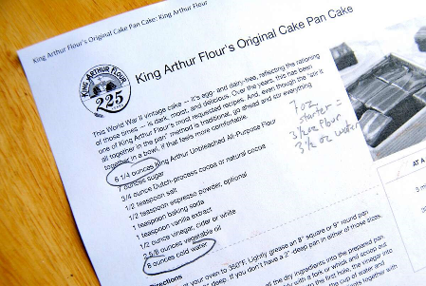
The recipe calls for 6 1/4 ounces flour and 8 ounces cold water, so it's a good recipe to use.
I have 7 ounces of "discard" starter (a scant 1 cup). That's 3 1/2 ounces each water and flour.
So I'll add that 7 ounces of starter to the recipe; and reduce the amount of flour and water in the recipe by 3 1/2 ounces each: meaning in addition to the starter, I'll use 2 3/4 ounces flour and 4 1/2 ounces water.
Stay with me here; if you don't regularly bake with a scale you might feel a little foggy right now, but this is simple arithmetic.
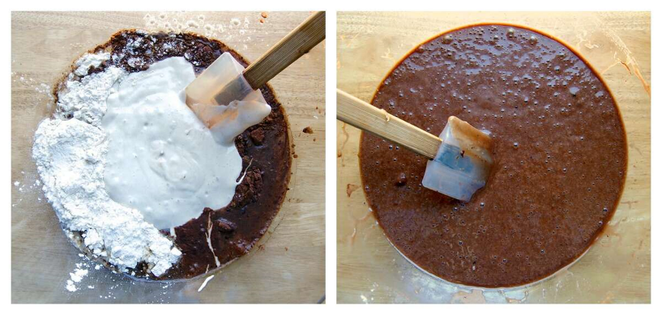
I mix everything together. See the discard starter plopped on top?
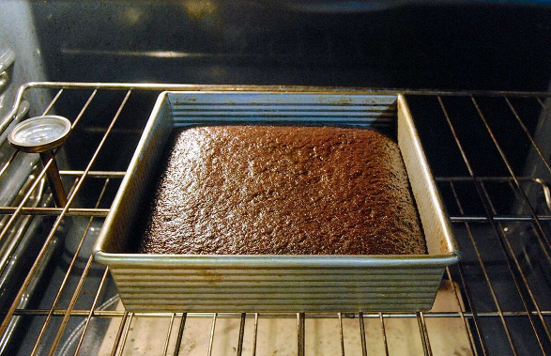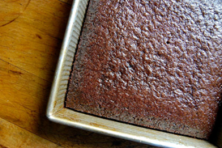
Bake.
The edges of the cake are just barely pulling away from the sides of the pan – that means the cake is fully baked.
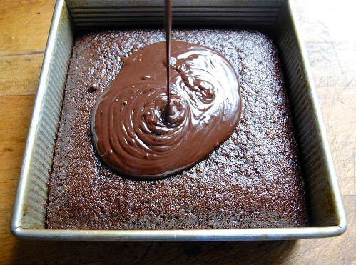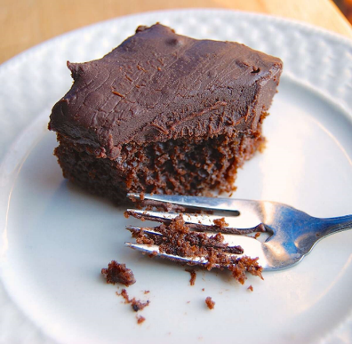
I pour a simple icing on top...
...and there you have it, Cake Pan Cake made with discarded sourdough starter.

Adding sourdough to a recipe for yeast bread.
Now let's try this same process in one of my favorite bread recipes, English Muffin Toasting Bread. While you can substitute unfed starter in yeast bread, I like to give my bread a little extra oomph by subbing fed starter instead.
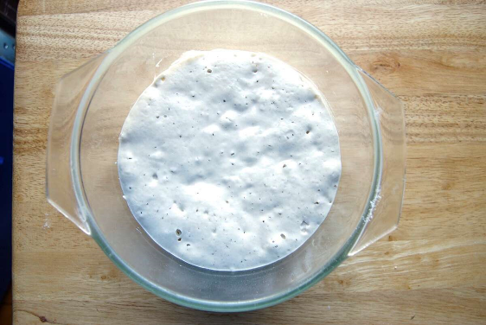
Here's my fed starter, fully ripened and ready to go. (For you sourdough newbies, "ripened" means fed and bubbly.)
The English Muffin Toasting Bread recipe calls for 3 cups (12 3/4 ounces) flour, 1/4 cup (2 ounces) water, and 1 cup (8 ounces) milk.
I'm using 8 ounces of ripened sourdough starter. So that means I need to reduce the flour by 4 ounces (to 8 3/4 ounces); and reduce the liquid by 4 ounces by eliminating the water (2 ounces), as well as 2 ounces of the milk.
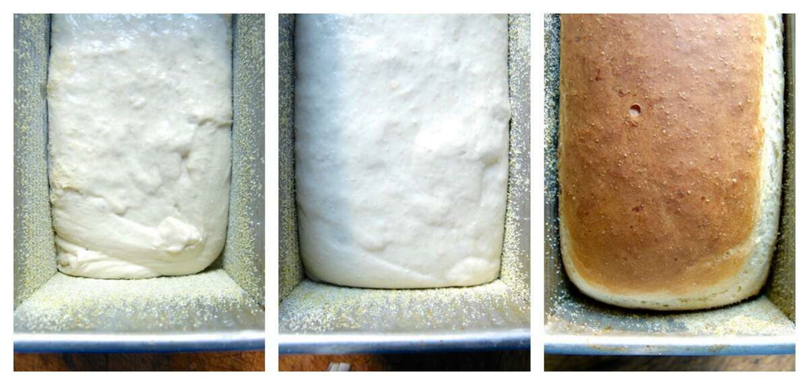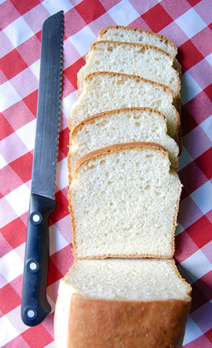
The batter looks the same as it usually does (left). It rises nicely (center). And bakes up beautifully (right). The finished loaf slices nicely. And the taste? It's not sour, but rather seems richer compared to my usual toasting bread. It's as though the starter simply enhances the bread's natural wheat/milk/butter flavor.

Adding sourdough to all kinds of recipes.
Using sourdough starter, either fed or unfed, is possible in a wide range of recipes – so long as the recipe includes sufficient water/flour for you to substitute your starter.
A cookie recipe wouldn't work well; cookie recipes generally don't include significant amounts of water or milk. But muffins, biscuits, pancakes, scones... all of those usually include enough liquid for the substitution to work.
One thing to keep in mind: when you're substituting sourdough starter in a recipe calling for milk, you'll lose something: milk fat and milk solids, which add flavor and enhance texture. You may be willing to make the tradeoff, but it's useful to manage your expectations ahead of time.

10 tips for new sourdough bakers
Sourdough starter is a combination of water and flour which, when mixed together, grows wild yeast, produces organic acids, and attracts friendly bacteria. All flours, from whole grain rye to all-purpose white, harbor wild yeast and will cultivate bacteria. But not all flours work the same: some are better right at the beginning of your starter’s life, while others have more to contribute farther along in the process.
Maybe you have a good supply of bread flour but your starter recipe calls for all-purpose (or vice versa). Perhaps the formula lists organic rye flour or white whole wheat, and you simply don’t have them and can’t get them. No worries; just use what you have.
If your starter calls for all-purpose flour and all you have is bread flour, increase the water a bit; if it calls for bread flour and all you have is all-purpose, decrease the water a bit. And if it calls for whole wheat or rye and you have neither? Your starter may be a bit slower coming to life without the initial “kick” of a whole grain, but eventually it’ll work just fine.
One caveat: Bleached flour may eventually yield a decent starter, but due to its natural flora having been killed by bleaching it’ll probably take a heck of a lot longer for a starter made with bleached flour to become fully active.
Our Baking School keeps its starter in food-safe plastic buckets and uses metal spoons or acrylic spatulas to mix it up after feeding. I wouldn’t recommend using a bowl that’ll react with sourdough’s acidity — for instance, don’t mix or store your starter in cast iron or uncoated aluminum — but other than that, glass, plastic, stoneware, acrylic, stainless steel — take your pick, all are acceptable.
It’s certainly discouraging to see a starter that’s seemed perfectly happy suddenly turn into a lifeless blob. But it’s OK. As your new starter evolves, one set of bacteria gradually gives way to another; and during that transition, when neither is dominant, your starter will take a rest. Just keep feeding it; within a few days it should show renewed signs of life.
If you don’t remove some of your starter before feeding it, you’ll soon have gallons of the stuff filling your fridge. So yes, you DO have to remove some starter; but you don’t necessarily have to throw it away. Here are your options:
•Give your excess starter to a friend to start his or her own starter.
•Turn it into something yummy. Within the first 4 or 5 days of your starter’s life it won’t taste very good and probably shouldn’t be used for baking; but after that, there are many, many delicious ways to use it. See our collection of sourdough discard recipes for inspiration.
•Substitute it for some of the flour and water in your non-sourdough recipe. For details, see Adding sourdough to a recipe.
You also have the option of building and maintaining a much smaller starter, one that’s fed and discarded in tablespoons rather than cups. See our recipe for a smaller sourdough starter.
If you want to feed and store your starter in the same container, you want one that’s large enough to hold triple your volume of starter. If you’ll be feeding your starter in a bowl then transferring it to a lidded container to store, the container only needs to be a bit larger than the starter itself.
It’s handy to use a clear glass or translucent plastic container if you’ll be letting your starter rise in it, so you can track its progress. Stoneware, plastic, stainless steel, and enameled metal are also suitable materials.
Whatever vessel you choose the lid should fit securely, simply to prevent potential spillage if you knock the container over. But you don’t want anything airtight: it’s not necessary and could potentially result in a messy blowout.
A fed starter should double in size within 6 to 8 hours, or it probably won’t be strong enough to raise your dough.
Sometimes starter is so thin and liquid-y that there’s not enough structure for it to expand; bubbles simply rise and escape. If your starter seems thin (easily pourable rather than gloppy), try feeding it a bit more flour until it thickens up; alternatively, you can feed it with higher-protein (higher-absorption) bread flour. This might be just what it needs to start growing up, rather than fizzling out.
While sourdough starter can die under extreme circumstances (e.g., having been fed with boiling water), it’s actually really hard to kill. It may be poky and slow; it may not look like you think it should. But it’s not dead. Keep feeding it on a regular schedule and eventually it’ll start bubbling again.
Now, sourdough starter can very rarely become “infected” with mold or an evil bacteria, in which case you won’t want to bake with it. If your starter shows evident signs of mold or if it develops a pink/orange tinge, it’s time to discard it and start again.
When it comes to how your starter smells, it's fairly common for a fledgling starter to go through a stinky period (think teenagers' sneakers), but an established starter should never smell awful. That being said, if you've neglected your starter in the refrigerator longer than usual and it smells a little off, a few days of room-temperature feedings will likely restore it to its usual pleasant aroma.
For more on how to assess your starter's health see our post, Sourdough starter troubleshooting.
A banneton (a.k.a. brotform) is simply a round or oval basket that holds dough as it rises. The risen loaf is then turned out onto a baking stone, a baking sheet, or into a Dutch oven to bake. It’s useful for doughs that are quite soft and need support, keeping them from flattening out as they expand.
You can actually fashion your own rising vessel from a bowl and smooth dish towel, for soft dough. For a stiffer dough, simply allow the loaf to rise on a piece of parchment (which makes it easy to transfer to a hot baking stone); on the baking sheet on which you’ll bake it, or even in your Dutch oven if you decide not to preheat it first.
Rice flour is used to flour your banneton; it’s “slipperier” than regular all-purpose or bread flour and offers better release of the potentially sticky dough but again, not necessary.
A Dutch oven or other closed container is a real boon if you enjoy bread with excellent loft and supremely crusty crust. The container’s lid catches steam from the baking loaf, keeping its top crust soft and allowing it to expand fully. That same steam makes the crust crackly-crisp once the loaf has finished rising and the bread starts to brown.
Yes, a Dutch oven is great to have; see the details here: Bread baking in a Dutch oven. But you can certainly bake a lovely loaf without one.
Our Rustic Sourdough Bread is perfect for beginners. Since it includes a bit of commercial yeast as well as sourdough starter, you don’t have to worry about your starter being totally up to snuff: call it the belt and suspenders approach. While sourdough purists will argue that using commercial yeast disqualifies your bread as “true” sourdough, hey, what’s in a name? If you enjoy a light-textured, crusty loaf with lovely tang, this one’s for you.
Our Naturally Leavened Sourdough Bread includes no commercial yeast, and relies entirely on a strong starter for its rise. So if you choose this recipe make sure your fed starter is very healthy and active, doubling in size within 6 to 8 hours of feeding. If your starter is ready to go, expect to make a loaf with great crust and chew, and deep, rich sourdough flavor.
The wild yeast and friendly bacteria that bring sourdough starter to life are fickle, just like all living organisms. Sometimes they’re full of energy and ready to rise and shine; other times they need coddling and cajoling. It’s up to you to figure out what your starter needs — and when — in order to keep it happy and working for you.
It sounds daunting, but don’t be discouraged. Gradually, as you learn what works in your kitchen (rather than what works for that guy on YouTube or your best friend in Seattle) you’ll relax and realize that hey, sourdough bread's not that complicated after all. It’s flour, water, salt, and time — both the hours it takes your loaves to rise, and the days you spend learning about this ancient craft through practice, practice, and more practice.
Want to cut through the clutter of conflicting advice you find online? Read our guide to Sourdough Baking, a carefully crafted, professionally vetted approach to creating, baking with, and maintaining your own sourdough starter at home. And whatever baking challenge you're experiencing — from a sluggish sourdough starter to cake that caves — call, email, or chat with our Baker's Hotline folks. We're here to help!

